**PROJECT REPORT**

**INTRODUCTION:**

**TITLE OF PROJECT :**

**“4 – BIT ALU”**

**GROUP MEMBERS :**

1. ABDUL BASIT (20K-0333 , E2)
2. YASIR JAMAL (20K-0158 , E1)
3. ANAS HASSAN (20K-1726 ,E1)
4. MUHAMMAD WARZAN (20K-1649 ,E2)

**METHODOLOGY :**

In our project , we have performed addition , subtraction and comparison of two 4 – bit binary numbers along with both hardware and software implementation except multiplication which is carried only in software.

**ELECTRONIC COMPONENTS :**

* **FOR ADDITION :**

4- bit full adder IC (74LS83)

5 white Leds

* **FOR SUBTRACTION :**

4 – bit full adder IC (74LS83)

Inverter IC (7404)

4 green Leds

* **FOR COMPARATOR :**

XNOR IC (74266)

4 AND ICS (7408)

OR IC (7432)

2 Inverter ICS (7404)

3 yellow Leds

* **OTHER MAIN COMPONENTS :**

3 Breadboards , 9 – volt power supply , jumper wires along with simple wires and some 220 -300 ohm resistors .

**SOFTWARE USED :**

We have implemented whole circuit of our project in LogicWorks by dividing the whole circuit into several modules and testing each circuit operation individually .

**FLOW DIAGRAM :**

**ADDITION CIRCUIT :**

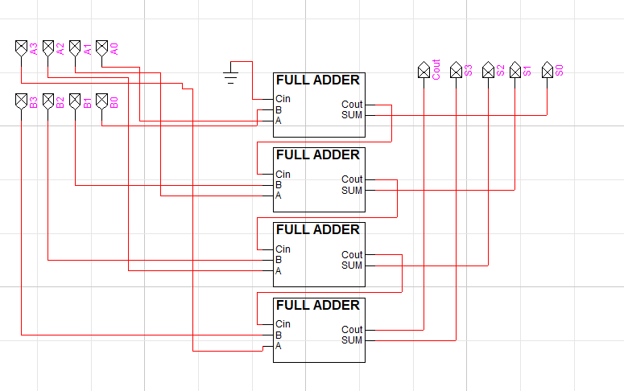

**SUBTRACTION CIRCUIT :**

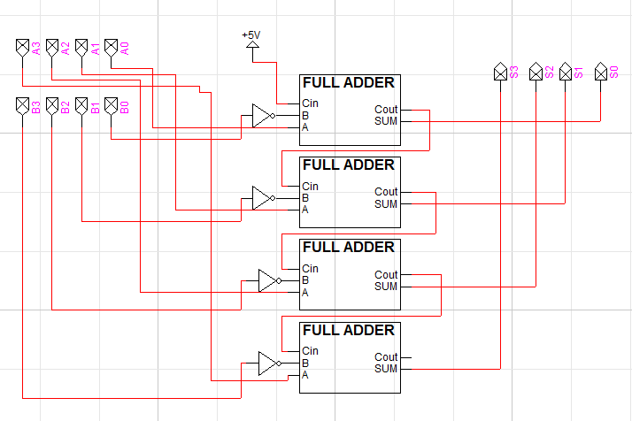

**MULTIPLICATION CIRCUIT :**

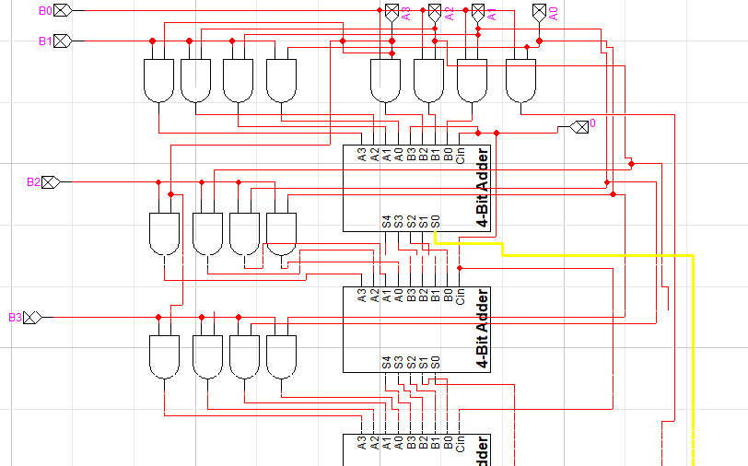



**COMPARATOR CIRCUIT :**

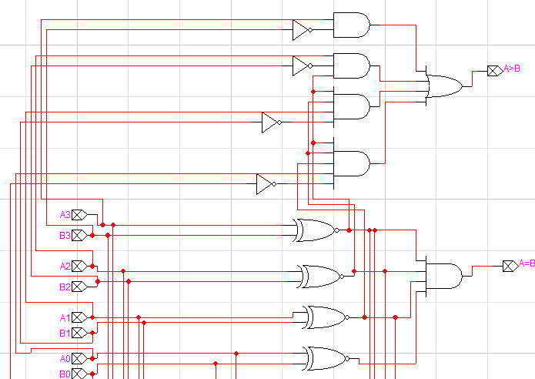

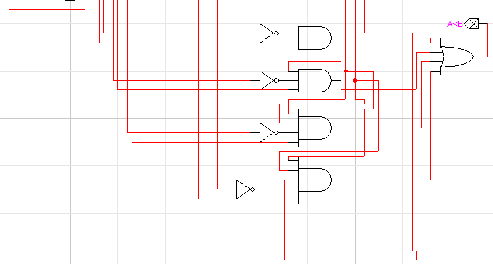

**OUTPUT WITH PROPER CAPTION :**

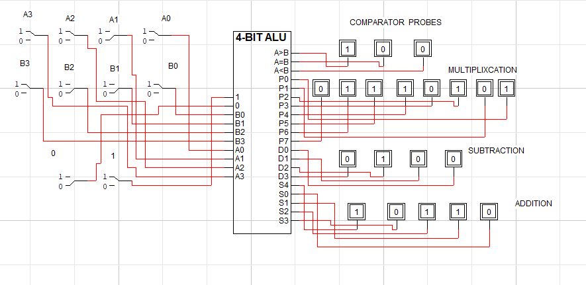

**FUNCTION / WORKING :**

We have used several ICS , Leds and 8- bit dip switches in implementation of project.

Addition and subtraction are performed in a single breadboard with a 8- bit dip switch that controls the output of both operations . 5 white and 4 green leds are used for this purpose respectively .

Similarly , comparator circuit is done in two breadboards due to complexity with a 8- bit switch and 3 yellow leds . Whenever one of the three conditions will be true , the respective led will be glown.

* A > B
* A = B
* A < B

**APPLICATION :**

An Arithmetic and Logic Unit (ALU) is a digital circuit used to perform arithmetic and logic operations . It represents the fundamental building block of the Central Processing Unit (CPU) of a computer.

**MOTIVATION :**

Since ALU is the most basic and fundamental part of the C.P.U , capable of performing all basic opertions . So , it motivates us to design such project which is capable of executing such operations .

**TASK DISTRIBUTION :**

All members of the group have equally participated in the hardware implementation of project but the workload distribution is given below.

* Abdul Basit (20K-0333) and Yasir Jamal (20K-0158) mainly worked on comparator circuit .
* Anas Hassan (20K-1726) and Muhammad Warzan (20K-1649) worked on addition and subtraction circuit.

**CONCLUSION :**

We have tried our best to design 4- bit ALU that is capable of performing all arithmetic and logic operations with proper captions and output shown on leds

**THANKING YOU**